Eg: Inheritance_Eg10

// here we are implementing getSales() method in the child class , if we are implementing we should use only the access modifiers that increases the visibility. So we used protected and private for method getSales().

Eg: Inheritance_Eg11

// binding will happen based on the reference type whether it is instance variables (or) static variables during inheritance

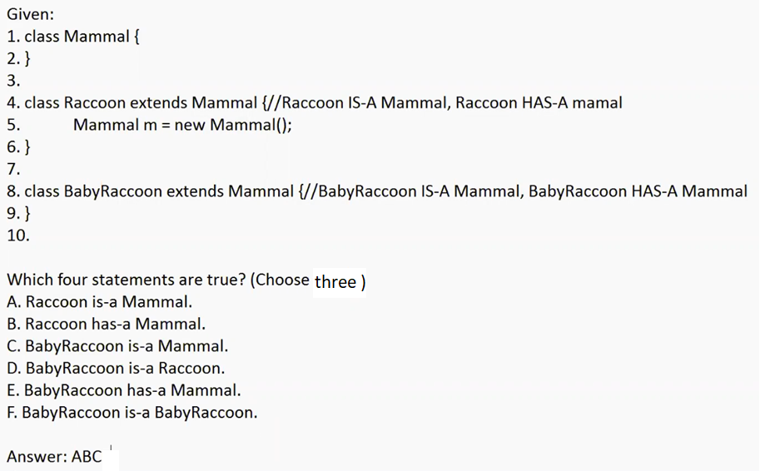

Eg: Inheritance_Eg12

// go through the code

Eg: Inheritance_Eg13

Here method overriding is done in the child classes Two and Three.

Here since return types are of parent class type, we must follow covariant return types.

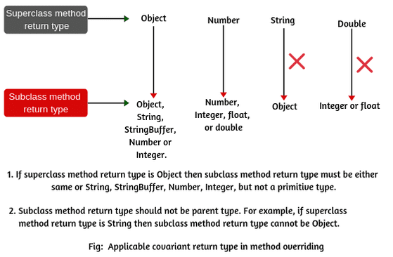

Eg: Bluegill

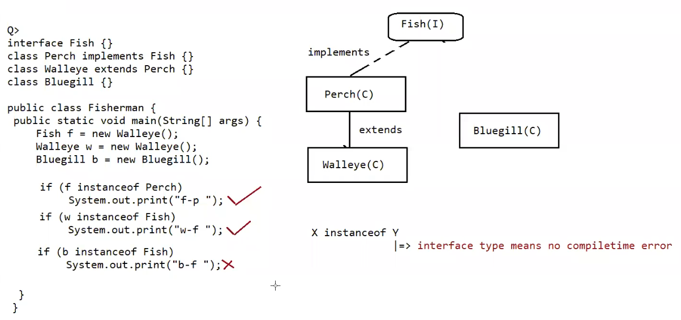

Here if X is a class and Y is an interface then no compile time error, relationship need not be

If there relationship is between class and class level, then class -class relationship should be there, that to parent-child (or) child to parent. no siblings relationship.

Eg: Inheritance_Eg14

Overridden method means based on the run time object the call will happen

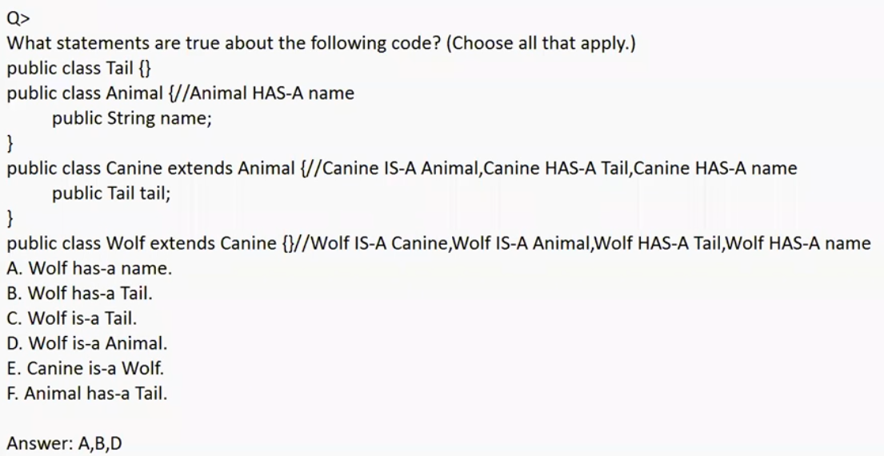

Eg: Inheritance_Eg15

// go through the code

Eg: Inheritance_Eg16

// go through the code